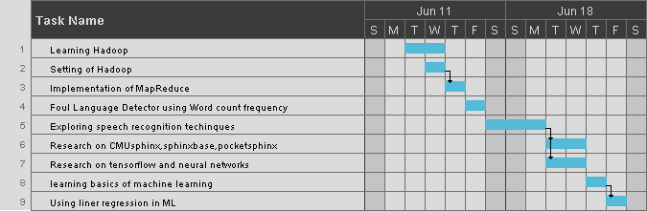**GANTT Chart (Week 1-2)**